Hyris COVID-19 Environmental Testing

The COVID-19 Environmental testing kit was born inside the Hyris labs, located in Lodi, the heart of the so called “red zone”. An efficient solution to detect contaminated areas and guarantee more safety.
Hyris, a leader in Artificial Intelligence applications for advanced Diagnostic with offices in London, Milan and Singapore created the bCUBE, a revolutionary portable DNA analysis platform, already commercialized and used in many countries worldwide, introduces today the kit to analyse COVID-19 Environmental contamination.
The kit identifies contaminated surfaces which represent a potential threat (if touched with hands or e.g. used to prepare food) and takes about an hour.
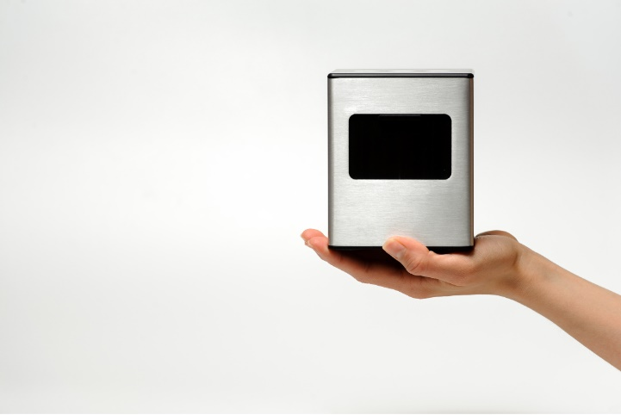
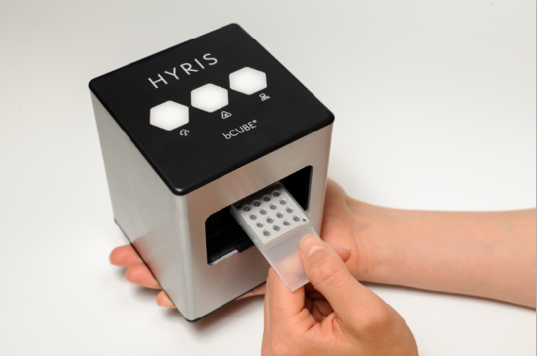
The patented technology on which it is based has been developed at the Hyris R&D Centre in Milan, Italy and is in use in Europe, North America and Asia in cooperation with top international research institutes.

The kit itself is based on one of the World Health Organization (WHO) recommended COVID-19 tests, currently adopted by several of the major diagnostic centers fighting the pandemic.

Stefano Lo Priore, Managing Director di Hyris, comments:” The COVID-19 Environmental testing kit is the outcome of the RD efforts of our team, coordinated by Lorenzo Colombo. This test is a tool to increase safety in work environments, which is critical as companies all over the world prepare to fully resume activities. The kit is intended for industries, transportation and epidemiological monitoring companies and takes advantage of the already consolidated and proven Hyris technological platform.
The bCUBE is a miniaturized portable device which doesn’t require particular skills to be installed or used, just a smartphone or a tablet. The bCUBE has an integrated module of Artificial Intelligence for data diagnostic and is handled by a user-friendly web app managing the data on the cloud, compatible with the major operating systems.”
Moreover, he continues “the same platform already has applications, consisting of dedicated reagent sets developed and produced by Hyris and its partners, for the detection of a wide microbiology catalogue (bacteria, viruses, parasites, etc.). The utility of these applications goes beyond the current COVID-19 pandemic.”
The bCUBE kit for environmental contamination is commercialised as a turn-key product including training and specifically developed swabs for environmental surfaces sampling (door handles, keyboards, boxes, food-prep counters, etc.). Hyris is already preparing the first deliveries of the kits to its partners is Europe and North America.

Hyris is already at work on a new and faster version of the kit which promises to deliver results in 10 minutes, with 3 times more samples per run. The estimated launch date is October 2020.

Scientists at two major American Universities comment about the bCUBE
”My research team compared 10 different miniaturised PCR units and verified, based on the achieved results, that Hyris bCUBE is by far the best device on the market. The added value of a sophisticated IT platform, cloud based, and of advanced algorithms grants users a dynamic access to the results in just over an hour. I’m not aware of any other PCR instrument with these features “. Steven Newmaster, Director, NHP Research Alliance, University of Guelph
“We have been using the Hyris bCUBE to run molecular assays for pathogen detection, and it has provided excellent performance, even when compared with much more expensive instrumentation” George Dimopoulos, Professor Department of Molecular Microbiology and Immunology, Bloomberg School of Public Health, Johns Hopkins University.

About Hyris LTD
Hyris is multinational company with a RD laboratory, active in the Advanced Diagnostic field, supported by Artificial Intelligence technologies and commercially present in USA, Europe and Asia. Founded in 2014 by an entrepreneurial team of engineers specialized in the Biotechnology sector and with past experience gained in the United Stated. The company has offices in London and Milan while the R&D lab is in Lodi, in the middle of the so called “red zone”. The affordable price, the swiftness to get the results and the advanced Artificial Intelligence software architecture differentiate Hyris technologies from the ones available on the market, as well as the capability of enabling “on the edge” test, close to the locations, where the diagnostic tests are required. The applications, initially aimed to the industrial genetic, rapidly evolved switching to other fields (pharmaceutical, virologic, epidemiologic, etc.) confirming once more the great flexibility and adaptability of the technologies.

Download images
Press contact
Halo Comunicazione
Rosanna Cognetti
+ 39 3358149782
rosanna@halocomunicazione.it

